**Emergencies**

**Reasons to call:**

**Medical emergency**

**Car Accident**

**Fire**

**House break-in**

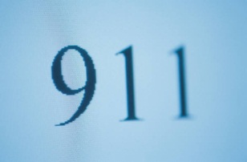

**Dial 9-1-1 to contact:**

**Police C:\Users\hcroy\AppData\Local\Microsoft\Windows\Temporary Internet Files\Content.IE5\8KVP8B8S\MC900013641[1].wmf**

**Fire Department C:\Users\hcroy\AppData\Local\Microsoft\Windows\Temporary Internet Files\Content.IE5\8KVP8B8S\MC900251108[1].wmf**

**Medical Services C:\Program Files\Microsoft Office\MEDIA\CAGCAT10\j0211949.wmf**

**Remember:**

**Stay calm**

**State the address of the emergency**

**State what the emergency is**

**Stay on the phone until 9-1-1 person end the call.**